Intransitive Verbs

🔹 What is Intransitive Verbs
# Source: AI Source: Provided by: [Data Path: Persons Table -> ID Column: 1, Name_En Column: Motasem Essam] -> From: [Chatgpt (GPT-4-turbo)] on [7/27/2025]
An intransitive verb is a verb that does not take a direct object. The action does not transfer to an object — the verb stands complete on its own.

✅ Definition:
# Source: AI Source: Provided by: [Data Path: Persons Table -> ID Column: 1, Name_En Column: Motasem Essam] -> From: [Chatgpt (GPT-4-turbo)] on [7/27/2025]
An intransitive verb is a verb that does not require a direct object to complete its meaning.

🧠 Test:
# Source: AI Source: Provided by: [Data Path: Persons Table -> ID Column: 1, Name_En Column: Motasem Essam] -> From: [Chatgpt (GPT-4-turbo)] on [7/27/2025]
Ask "What?" or "Whom?" after the verb.
If the answer doesn’t make sense or isn’t needed → the verb is intransitive.

📚 Examples in Sentences:
# Source: AI Source: Provided by: [Data Path: Persons Table -> ID Column: 1, Name_En Column: Motasem Essam] -> From: [Chatgpt (GPT-4-turbo)] on [7/27/2025]
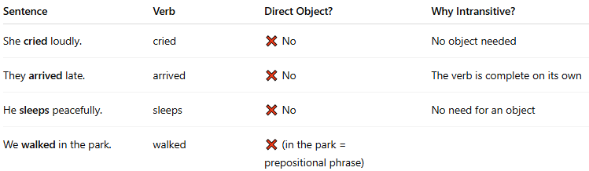
Sentence | Verb | Direct Object? | Why Intransitive?
She cried loudly. | cried | ❌ No | No object needed
They arrived late. | arrived | ❌ No | The verb is complete on its own
He sleeps peacefully. | sleeps | ❌ No | No need for an object
We walked in the park. | walked | ❌ (in the park = prepositional phrase)
✅ “She cried.” = complete
❌ “She cried what?” = doesn’t make sense → intransitive

🔁 Intransitive vs Transitive Verbs:
# Source: AI Source: Provided by: [Data Path: Persons Table -> ID Column: 1, Name_En Column: Motasem Essam] -> From: [Chatgpt (GPT-4-turbo)] on [7/27/2025]
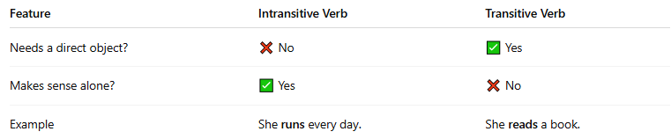
Feature | Intransitive Verb | Transitive Verb
Needs a direct object? | ❌ No | ✅ Yes
Makes sense alone? | ✅ Yes | ❌ No
Example | She runs every day. | She reads a book.

⚠️ Some verbs can be both:
# Source: AI Source: Provided by: [Data Path: Persons Table -> ID Column: 1, Name_En Column: Motasem Essam] -> From: [Chatgpt (GPT-4-turbo)] on [7/27/2025]
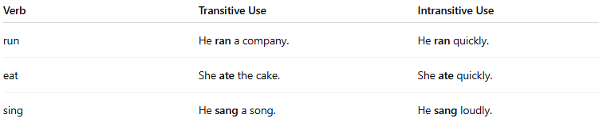
Verb | Transitive Use | Intransitive Use
run | He ran a company. | He ran quickly.
eat | She ate the cake. | She ate quickly.
sing | He sang a song. | He sang loudly.

✅ Summary:
# Source: AI Source: Provided by: [Data Path: Persons Table -> ID Column: 1, Name_En Column: Motasem Essam] -> From: [Chatgpt (GPT-4-turbo)] on [7/27/2025]

Property | Intransitive Verb
Takes direct object? | ❌ No
Complete by itself? | ✅ Yes
Examples | go, come, sleep, laugh, die
Common test | Can’t answer “what?” or “whom?”

